Digital Krushi Officer

User Manual

EDITION  14 October 2026 |  | AUDIENCE  Farmer Officer Admin |  | LANGUAGE  English

Website | digital-krushi-officer.onrender.com
Purpose | A practical guide to every role and its workflow
Examples | Fictitious demo records and illustrative values
Scope | Current website features and common troubleshooting

Contents
Use the section numbers to find an action quickly. The opening overview explains the roles; each later topic includes steps, an example and relevant limits.
Sections | Topics
1 to 4 | Website roles • registration • sign-in • language and navigation
5 to 9 | Farmer dashboard • AI conversations • photos and voice • expert routing • mandi prices
10 to 16 | Add and edit crops • suggested calendar • custom reminders • task actions • email • harvest
17 to 21 | Query history and ratings • disease library • weather • schemes • farmer profile
22 to 26 | Officer dashboard • review and approve • revise a draft • reply or reject a case • profile
27 to 30 | Admin dashboard • account access • farmer assignments • unassigned query routing
31 to 34 | Shared crop catalog • government schemes • disease dataset • queries feedback and analytics
35 and 36 | Troubleshooting • complete practice workflow

How to read the examples
Asha Patel is the demo farmer and Meera Shah is the demo Krushi Officer. North Field is an example field. Dates, crop observations and task titles explain how to use the forms; they are not instructions for your own farm. Use the actual facts from your field.
Screenshots show the English interface. Icons are visual aids; follow the named button or menu. Long forms continue below the visible area, so scroll when a described control is not yet visible.

Quick start
Farmers: sections 2 to 7 and 10 to 15. Officers: sections 22 to 26. Administrators: sections 27 to 34. For errors and missing messages, start with section 35.

1 Understand the website
Digital Krushi Officer helps farmers ask agricultural questions, maintain crop records and track planned work. AI handles everyday questions first. A Krushi Officer reviews difficult cases that remain uncertain; an administrator manages accounts, assignments and reference information. This manual explains the current website as of 14 October 2026.
Role | What you can do
Farmer | Ask AI, attach photos, manage your own crops and reminders, read officer replies, check weather and schemes, and rate answers.
Krushi Officer | Review assigned difficult cases, correct private AI drafts, reply to farmers, and maintain your professional profile.
Administrator | Manage farmer and officer access, assign unassigned cases, manage shared crop, scheme and disease records, and inspect queries and feedback.

Example
Asha adds Bajra in North Field, asks AI about that crop, records a soil-moisture check and completes the task after checking her field.

What to know
Screenshots throughout this guide use fictitious users in an isolated demo of the current website. Weather, answers, counts, dates and email status shown are illustrative. They do not prove a live forecast, diagnosis or message delivery. Open the real website at https://digital-krushi-officer.onrender.com. A free hosting service may take time to wake up after inactivity.

2 Create and verify an account
Choose the correct role when registering. Farmer and Officer accounts use the public registration form. Administrator accounts are provisioned separately.
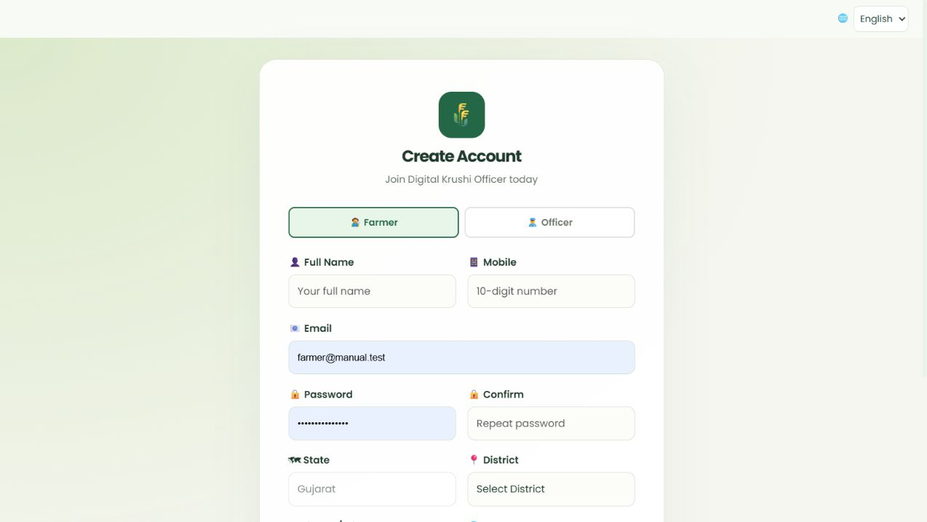
Figure 1. Create and verify an account in the demo website.
- Open the website and select Get started or Register here from the login page. Choose Farmer or Officer.
- Enter your name, 10-digit mobile number, email and matching passwords. Follow the form password rules; the minimum length is 10 characters.
- Select the available state, district and village or city, then your preferred language. Complete any role-specific details shown and select Create Account.
- Open the verification message in your email and follow its link. Use the verification or resend instructions if the account is not yet verified.
- Farmers can sign in once their account is verified and active. Officers also need administrator activation before using their workspace.

Example
A farmer selects Gujarat → Ahmedabad → the appropriate village, verifies their own email and signs in. An officer verifies their email and waits for the administrator to activate the account.

What to know
This release has English, Hindi, Gujarati and Marathi interface options. The registration location list currently covers Gujarat; language support does not imply that every state is available in this form.

3 Sign in and manage passwords
Use your own email and password. Sign-in opens the workspace for your account role.
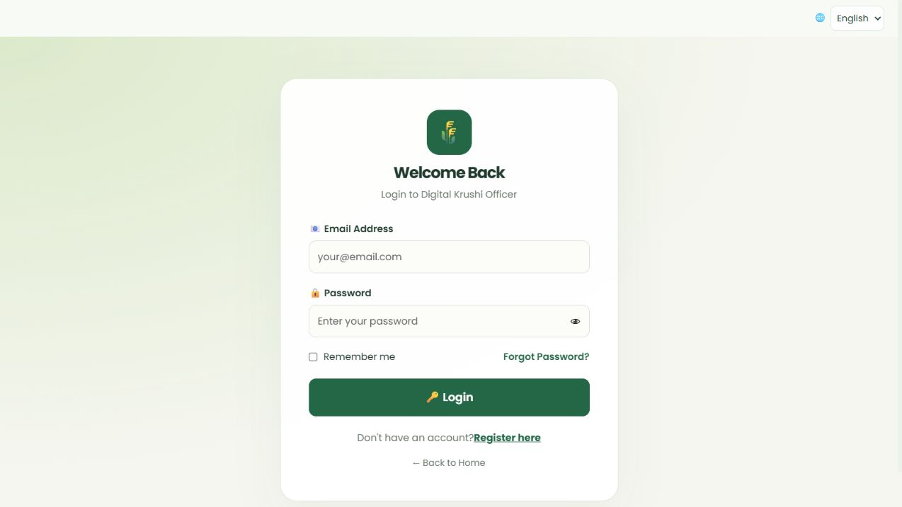
Figure 2. Sign in and manage passwords in the demo website.
- Enter Email Address and Password, then select Login. The eye button shows or hides your typed password.
- Select Remember me only on a device you trust. On a shared device, leave it unchecked and use Logout when finished.
- If you forgot your password, select Forgot Password, enter your email and follow the reset link sent to that address.
- When already signed in, select Change password in the sidebar. Enter the current password and the new password twice, then submit.
- If sign-in is blocked, check email verification and account activation. An officer may be verified but still awaiting administrator approval.

Example
You cannot remember your password: use Forgot Password rather than creating a second account. If no message arrives, check spam and the email spelling before requesting another link.

What to know
Verification and reset links are time limited. Request a fresh link if the old one has expired. Repeated sign-in attempts can be temporarily limited; wait before retrying. Never share a password or reset link with another user.

4 Choose a language and use navigation
English is the default. The header Language menu lets you switch to Hindi, Gujarati or Marathi. Farmer Privacy appears beside it on the main farmer pages.
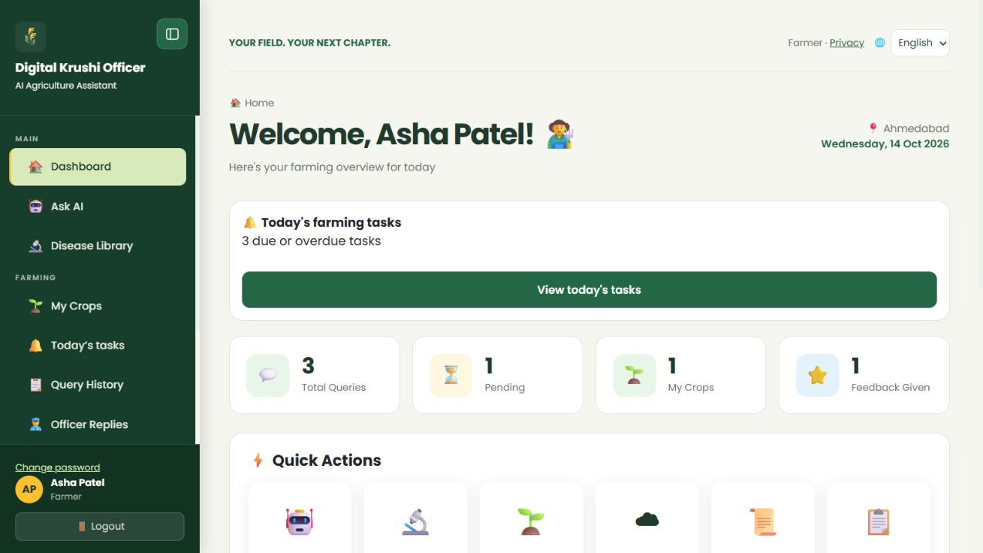
Figure 3. Choose a language and use navigation in the demo website.
- Select the language menu at the upper right and choose the language you understand best. The interface updates to that selection.
- Use the left sidebar to open your role’s pages. The navigation toggle hides or reveals the sidebar, which is useful on a small screen.
- Use dashboard quick actions for common tasks. Open Privacy to read how information is used.
- For a signed-in account, the language preference is saved for future use. You can also change Preferred Language from your editable profile.

Example
Select Gujarati before asking a new question. New AI output and reminder message templates use the saved language preference.

What to know
Previously saved answers and text you typed, such as a field name or custom reminder, are not automatically rewritten. Catalog content without a translation may retain its original language. Browser voice support can differ by language and device.

5 Read the farmer dashboard
The dashboard gives an overview of your own farming activity and shortcuts to the main tools.
Figure 4. Read the farmer dashboard in the demo website.
- Read Total Queries, Pending, My Crops and Feedback Given to understand your account activity.
- If today’s farming tasks are shown, select View today’s tasks to see due and overdue work across your growing crops.
- Use Ask AI for a question, My Crops for crop records, or History for past queries. Recent Queries shows the newest activity and its status.
- Check the district weather card and active crop summary. Open their dedicated pages for more information.

Example
Asha sees one pending question and three tasks due or overdue. She opens Today’s tasks, checks the field and marks only the work she actually completed as Done.

What to know
Pending is a workflow count, not a promise of response time. Weather cards are forecasts, not measurements from your field. An empty section usually means no matching records have been saved yet.

6 Ask AI and continue a conversation
Use Ask AI for everyday crop, soil and farm questions. Your question appears in the conversation, followed by the answer or the next step.
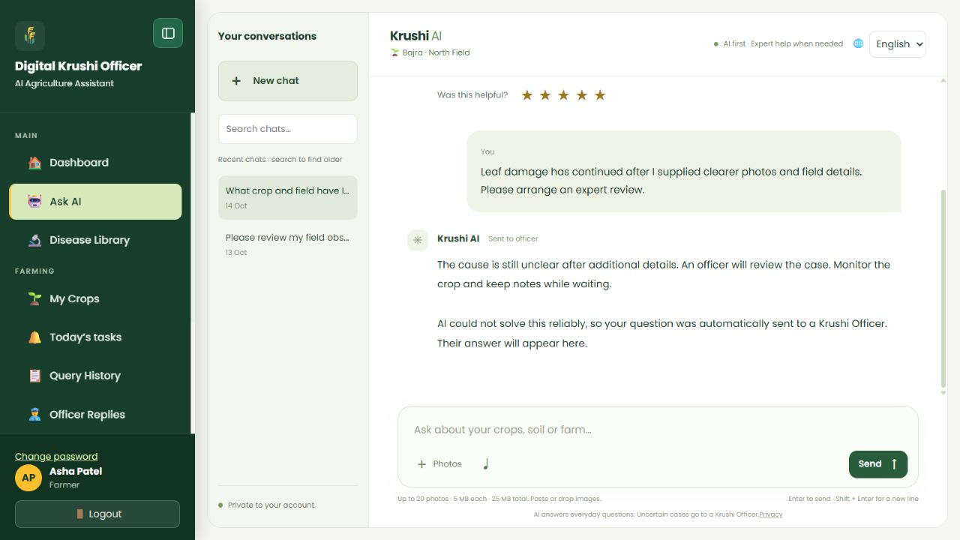
Figure 5. Ask AI and continue a conversation in the demo website.
- Select Ask AI. Start a New chat for a new topic or select an existing conversation on the left.
- Type one clear question with the crop, crop stage, symptoms or goal and location when relevant. Select Send or press Enter; use Shift + Enter for a new line.
- Read the answer. If AI asks for details, reply in the same conversation so it can use the earlier messages.
- Search chats to find an older conversation. Use Load earlier messages when available, and Jump to latest to return to the newest part of a long chat.
- Use the stars on a published answer to record whether it helped you. You can update your own rating.

Example
“My Bajra is 25 days old in Ahmedabad. The lower leaves are yellow, and the soil is wet after rain. What should I check first?” Follow up with the requested observations in the same chat.

What to know
Messages allow up to 4,000 characters. Asking several unrelated questions at once makes context less clear. If you see a temporary AI service error or RetryNeeded, retry later; a technical outage is not an expert diagnosis.

7 Attach multiple photos and use voice
Photos can help AI assess a crop problem. Clear images and a short explanation are more useful than many unrelated pictures.
Figure 6. Attach multiple photos and use voice in the demo website.
- Select Photos and choose multiple images. You can also paste or drop supported images into the composer.
- Include a full-plant view, a sharp close-up of affected leaves and any useful soil or field view. Remove unwanted attachments before sending.
- Describe what each image shows, when the issue started and how much of the field is affected. Send the photos with the question.
- To speak a question, use the microphone control in a supported browser. Allow microphone access only if you want voice input, then review the transcript before sending.

Example
Attach three photos: the full Bajra plant, the underside of an affected leaf and the soil surface. Add: “Photos taken today; symptoms started two days ago; about ten plants affected.”

What to know
Each message supports up to 20 JPG, PNG or WebP images, no more than 5 MB each and 25 MB combined. Send additional photos in a follow-up message. A blurred image may lead to a request for a clearer image; it does not automatically go to an officer. Voice input depends on browser permissions and support.

8 Understand AI answers and expert review
The website uses an AI-first workflow. Most questions and usable images are handled by AI; officers are involved when the agricultural case remains difficult or needs expert assessment.
What happens | What you should do
AI answers directly | Read the guidance and ask a relevant follow-up if needed.
AwaitingDetails | Provide clearer photos or the specific field observations requested in the same conversation.
PendingApproval or Escalated | An assigned officer is reviewing the case. Read the safe interim message and check back for the officer’s reply.
Unassigned | No suitable active, verified officer was assigned. The administrator can route the case from the review queue.
NeedsRevision | The officer kept an AI draft private while correcting it. Wait for a reviewed answer.
RetryNeeded | The AI provider was temporarily unavailable. Retry later; this alone should not require officer review.

Example
A clear leaf image may receive an AI explanation. If the cause is still uncertain after better photos and field details, the case can be escalated for local inspection or expert review.

What to know
A private draft is not a farmer-visible final answer. The website should not invent a disease, a crop variety or a current market price to fill missing information. Dates, field checks and local expert advice can affect what is appropriate for your crop.

9 Ask for mandi prices
For market prices, specify the commodity and location. The website first tries public official AGMARKNET weekly reports; the filtered data.gov.in connection remains available when the first source cannot supply a verified report.
- Ask a specific question such as “Show the latest wholesale Tomato price in Ahmedabad mandi, Gujarat.”
- If the crop or market is ambiguous, provide the requested commodity, state, district or mandi name.
- Read the report date, market, commodity or variety, reported price and source link together. Read minimum, maximum and modal values only when that source supplies them.
- Check the unit before comparing values. Reported prices are usually rupees per quintal; one quintal is 100 kg.
- If data is unavailable, use the official source link or ask again later. Do not treat an absent report as a price of zero.

Example
Ask “Onion price in Surat, Gujarat.” A checked official report showed Surat APMC, Onion - Other, ₹3,100 per quintal dated 12 October 2026. This historical example is not today’s confirmed price; ask again for the latest available report.

What to know
Weekly reports supply a reported price, without separate Min/Max/Modal fields. The chatbot names that APMC and marks an older date clearly. When Modal is supplied, it means the commonly reported price, not a guaranteed sale price. Wholesale, retail and MSP differ. Reports depend on market submissions; cached results may be reused for up to five minutes.

10 Create a crop record
My Crops is your personal portfolio. It records the crops you grow and links each record to its own calendar and AI conversation.
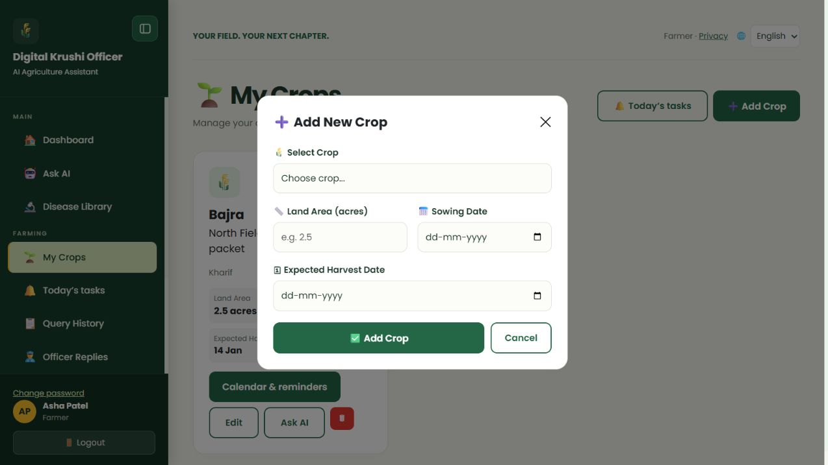
Figure 7. Create a crop record in the demo website.
- Open My Crops and select Add Crop.
- Select a crop from the catalog. If it is missing, choose Other / add your own crop and enter its name.
- Enter land area in acres if known, the sowing date and the expected harvest date. Use your actual plan rather than a guessed maturity date.
- Select Add Crop. The new crop appears as a card. Open Edit to record the field name and variety.
- Create separate records for different fields or sowing cycles so reminders and conversations stay clear.

Example
Select Bajra, enter 2.5 acres, sowing 14 October 2026 and estimated harvest 14 January 2027. Later enter North Field and the exact variety printed on the seed packet.

What to know
The current catalog has many crop types, but its count can change. Other creates a personal crop name; it does not add that crop to the shared admin catalog. My Crops does not have a search box in this release.

11 Edit crop details and share context with AI
Accurate records help you and AI discuss the same crop. A crop name such as Bajra is not a variety name.
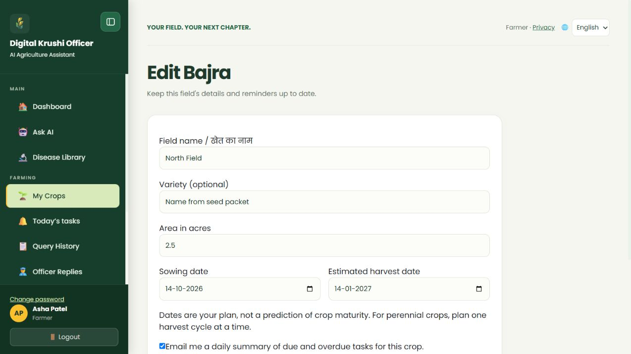
Figure 8. Edit crop details and share context with AI in the demo website.
- From My Crops, select Edit, or select Edit details from the crop calendar.
- Enter the field name, optional variety, area, sowing date and estimated harvest date. Enable email reminders only if you want them, then save.
- Select Ask AI on the crop card or Ask AI about this crop on the calendar. A new conversation includes that crop’s saved details.
- Read the compact crop label in chat to confirm which crop and field are attached. Supply missing details in the question if needed.
- If the sowing or expected harvest date changes, review and reschedule the existing reminders as well.

Example
“Which crop and field are selected?” can use Bajra and North Field from the saved record. If Variety is blank, AI should say the variety is not recorded; it must not guess a seed variety.

What to know
A field name is required when editing, with up to 100 characters; variety is optional, also up to 100. Harvest must not precede sowing and is limited to a two-year cycle. Saving crop dates does not automatically move every existing reminder. For perennial crops, plan one harvest cycle at a time.

12 Review and activate the suggested calendar
The calendar proposes general checks from preparation through estimated harvest. You decide whether the dates suit your field.
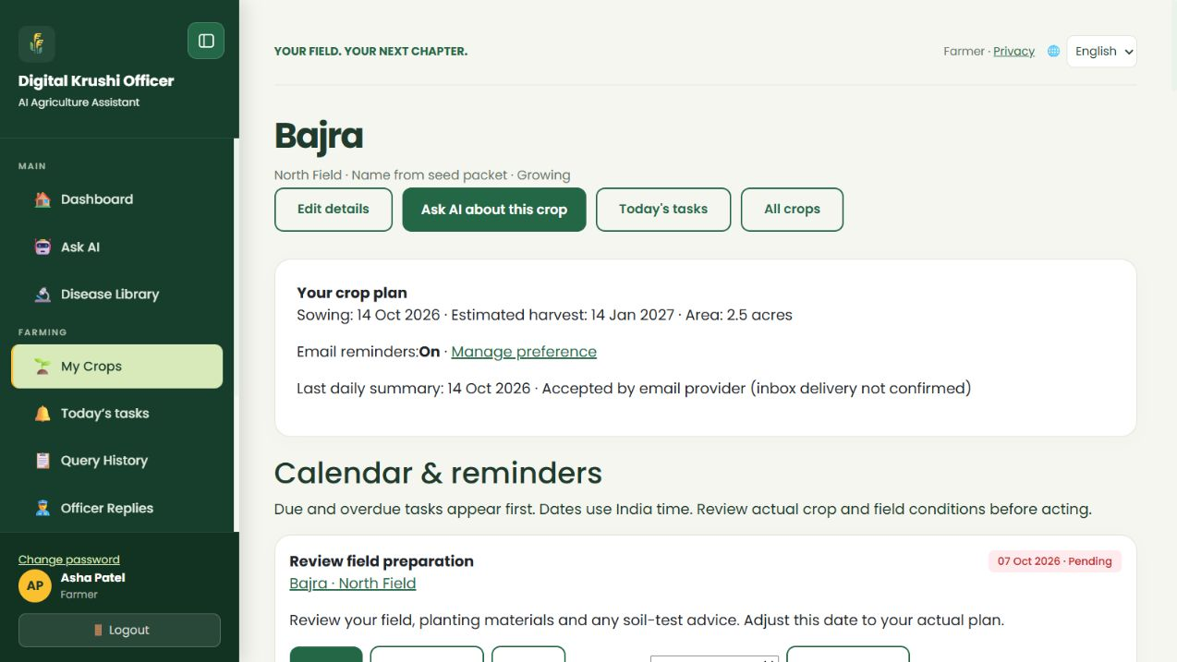
Figure 9. Review and activate the suggested calendar in the demo website.
- Open My Crops → Calendar & reminders.
- Expand Review suggested calendar — confirm before activating. Check the sowing and estimated harvest dates first.
- Review preparation, sowing, weekly crop and soil checks, harvest preparation and harvest readiness checks.
- Select Confirm these reminder dates when the suggested plan is suitable. The active task list then shows the accepted work.
- Reschedule unsuitable tasks and add your own reminders for work specific to your crop.

Example
A weekly crop check reminds you to look at growth, leaf changes and soil moisture. It is a prompt to observe conditions, not an automatic instruction to irrigate or spray.

What to know
Harvest dates are estimates. Confirming a revised plan replaces pending generated tasks while preserving custom tasks and completed or skipped history. Past suggested dates are not newly activated as overdue work. Crop-specific chemical schedules or guaranteed maturity predictions are not part of this generic plan.

13 Add your own reminder
A custom reminder records work that the general calendar does not cover. It can be scheduled for today to appear in website tasks.
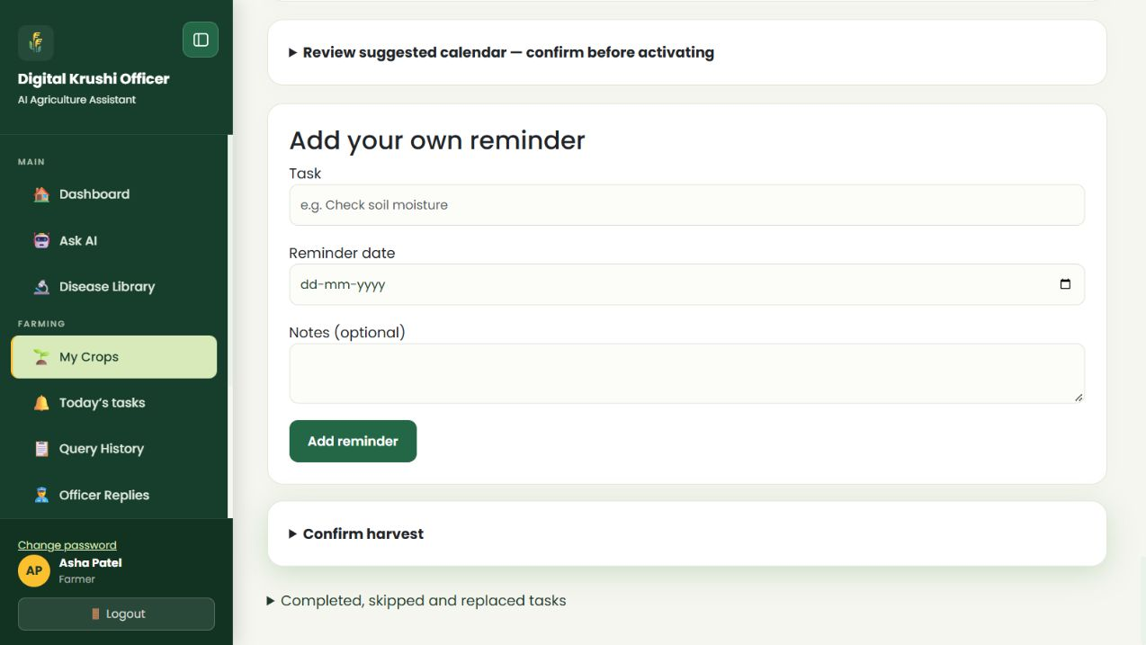
Figure 10. Add your own reminder in the demo website.
- Open the growing crop’s Calendar & reminders page and scroll to Add your own reminder.
- Enter a short Task title, choose Reminder date and optionally add Notes.
- Select Add reminder. Check that the task appears in the crop calendar with the intended date.
- If the date is today, open Today’s tasks to see it alongside other due and overdue work.
- To receive a daily email summary for this crop, also enable its email preference. Adding a task does not itself enable email delivery.

Example
Task: “Check soil moisture”. Reminder date: today. Notes: “Check the soil before deciding whether to irrigate.” After adding it, verify it in Today’s tasks and complete it only after the check.

What to know
Custom tasks are available for Growing crops. The title allows up to 160 characters and notes up to 1,000. Choose today or a future date within two years. A today task may miss a summary already sent earlier that day; an overdue pending task can appear in a later daily summary.

14 Complete skip or reschedule work
Today’s tasks combines due and overdue pending tasks across your growing crops. Dates use India time.
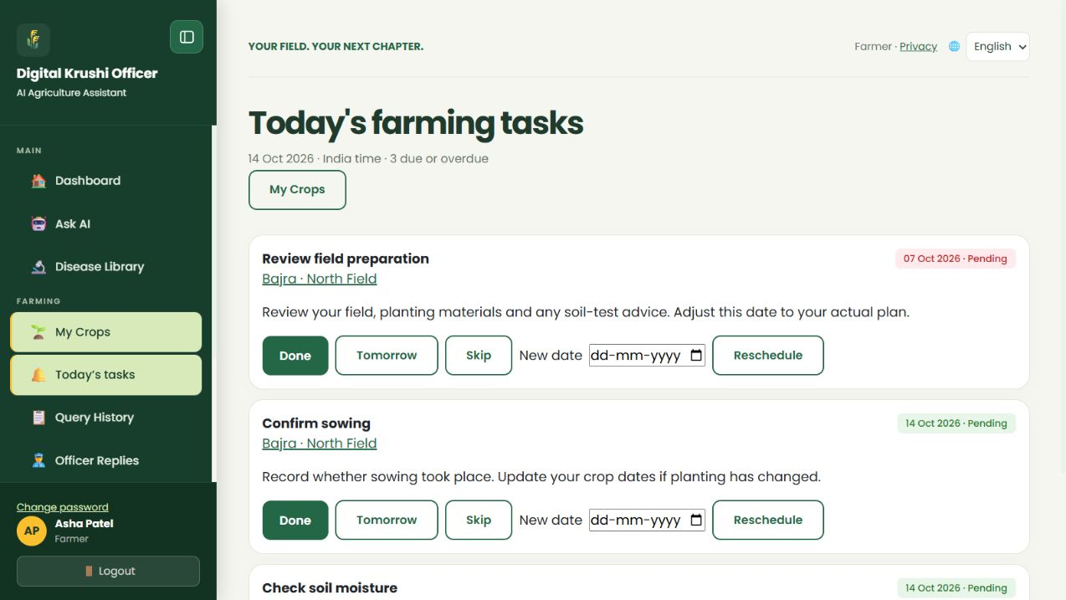
Figure 11. Complete skip or reschedule work in the demo website.
- Open Today’s tasks from the sidebar or the dashboard task banner. Read the crop and field on each task.
- Select Done only after completing that task. Select Skip when the planned task is not needed.
- Select Tomorrow to move a pending task to tomorrow. To choose another date, enter New date and select Reschedule.
- Open the crop link for the full calendar. Expand Completed, skipped and replaced tasks to review the task history.
- After a change, verify the new status or date. If another tab changed the same record, refresh before acting again.

Example
Rain delays a field check: choose Tomorrow or a suitable New date instead of marking it Done. A task whose date has passed stays overdue until you complete, skip or reschedule it.

What to know
Done applies to that reminder only. Completing a harvest-readiness check does not mark the crop harvested. Skipped and cancelled tasks are history records and should not be confused with unfinished pending work.

15 Enable and understand email reminders
Website reminders work independently of email. Email reminders are an optional daily summary of due or overdue tasks for opted-in growing crops.
Figure 12. Enable and understand email reminders in the demo website.
- Open the crop calendar and read Email reminders. Off means this crop is not opted in for email summaries.
- Select Manage preference or Edit details. Enable the email reminder option and save.
- Ensure your account email is verified and correct. Keep the preference off for crops whose emails you do not want.
- Check Last daily summary on the calendar. Accepted by email provider means the provider accepted the message, not that your inbox received it.
- To stop messages for a crop, turn its email preference off. Continue using website tasks normally.

Example
Asha opts in for Bajra and leaves another crop off. Her daily email combines due or overdue work only from the opted-in crop records. Completed, skipped and harvested-crop work is excluded.

What to know
The scheduler is configured for an approximately 9:07 am India-time run and a 10:07 am fallback. Free scheduled jobs and hosting can delay execution, so exact delivery time is not guaranteed. Normally there is one summary per farmer per day, not one email per task. Check spam and your preference if no email appears.

16 Record harvest and remove crop records
Use Confirm harvest when harvesting actually happened. An estimated harvest date or a completed check is not proof that the crop has been harvested.
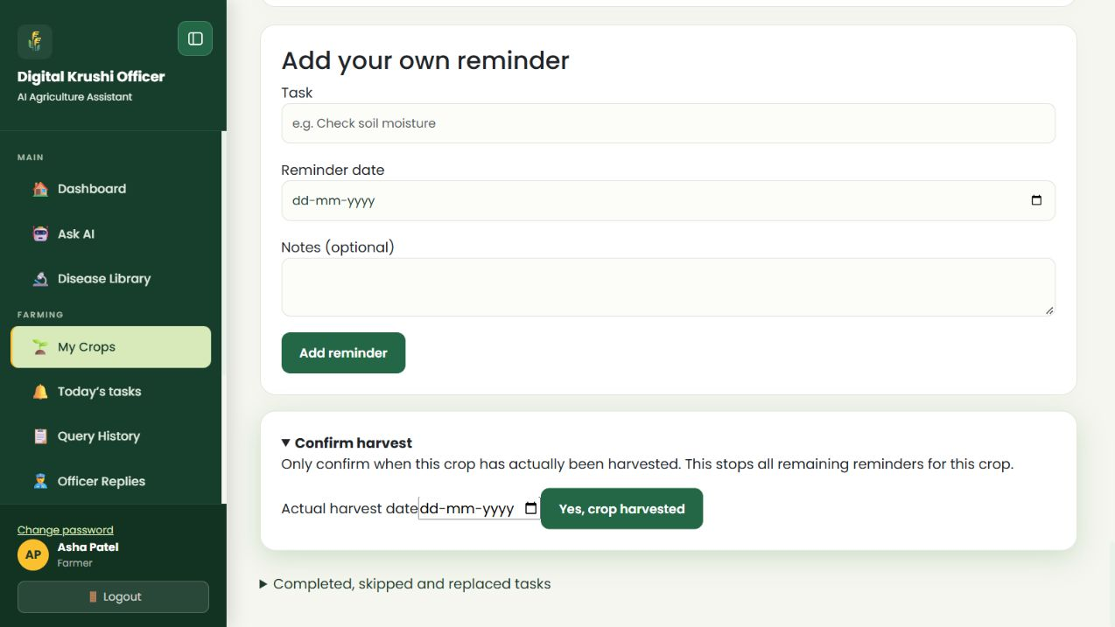
Figure 13. Record harvest and remove crop records in the demo website.
- Open the crop calendar and expand Confirm harvest.
- Enter the actual harvested date between the sowing date and today, then confirm after checking the field.
- Verify that the crop becomes Harvested. The harvest check is completed and remaining pending work is cancelled; the crop no longer contributes daily reminder emails.
- For another planting cycle, create a new crop record with its own dates.
- To remove an unwanted crop record, use the trash button on My Crops and read the confirmation carefully before accepting.

Example
The expected harvest date arrives, but the crop is not ready. Reschedule the readiness check and update the expected date. Confirm harvest only once harvesting has actually occurred.

What to know
Deleting a crop removes its personal record and calendar. It is different from marking the crop Harvested, which preserves the record and task history. Do not delete a useful crop record merely to stop emails; turn email reminders off instead.

17 Find queries replies and rate answers
Query History helps you find past questions. Officer Replies collects expert responses to your cases.
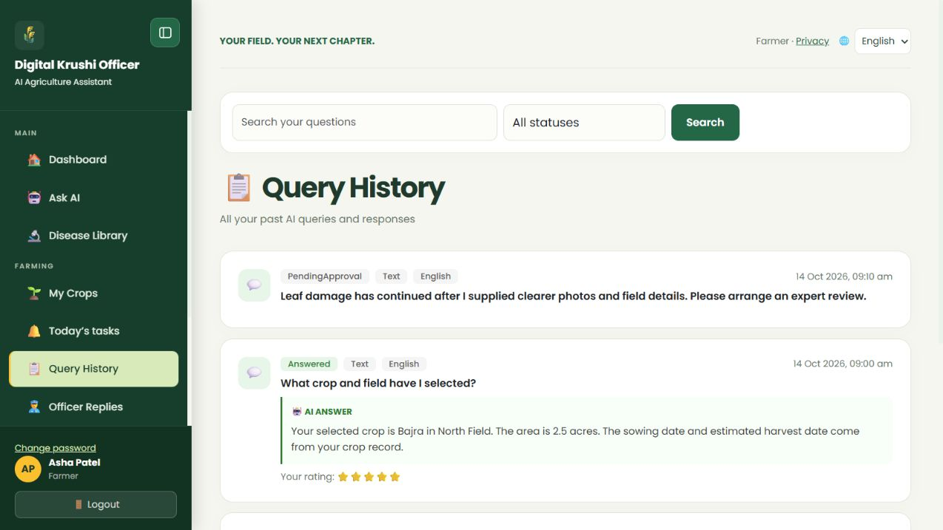
Figure 14. Find queries replies and rate answers in the demo website.
- Open Query History. Search for words from the question, select a status filter and apply the filter.
- Use the available page navigation for older results. Read the displayed answer summary; to continue or read the complete conversation, open Ask AI and select the matching saved chat.
- Open Officer Replies to read the assigned officer’s message and case status. A reply can be an update, a solved answer or a rejection reason.
- For published answers, choose a star rating from 1 to 5 and provide feedback where the form is available. You can change your own feedback.

Example
Search “leaf” to find a previous crop problem. Read the officer’s reason before starting a new case with better evidence. Rate a useful, understandable answer rather than only its speed.

What to know
PendingApproval means a draft is still under review. Rejected means an officer closed the case with a reason; it does not confirm that the crop is healthy. An In Progress reply is an update while the case remains open.

18 Browse the disease library
The Disease Library is reference material. It helps you compare symptoms and learn about possible problems; it does not confirm a diagnosis from your photo.
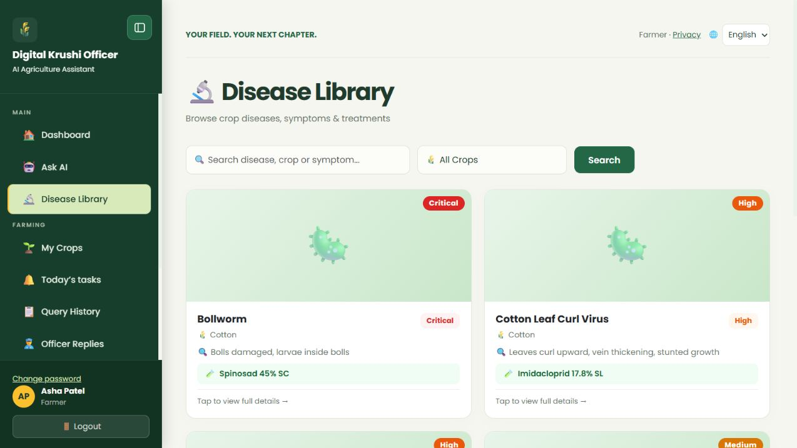
Figure 15. Browse the disease library in the demo website.
- Open Disease Library. Search by disease, crop or symptoms, or use the crop filter.
- Select a matching disease card to read its reference image, symptoms, solution, recommended pesticide information and severity.
- Compare the description with what you observe. If it does not clearly match, ask AI with your photos and field details.
- For persistent or uncertain cases, provide the requested clarification so an officer can review the case if needed.

Example
A farmer searches “yellow leaves” and filters by the crop. Similar symptoms can have several causes; the farmer asks AI to consider the actual crop stage and soil conditions before choosing an intervention.

What to know
Severity labels are Low, Medium, High and Critical. Catalog treatment text is general reference information. Confirm the local recommendation, product label and crop suitability before using a pesticide. A reference photograph is not a substitute for field or laboratory assessment.

19 Read the weather outlook
Weather displays a district forecast and its timestamps. Use it to plan work alongside what you observe in your own field.
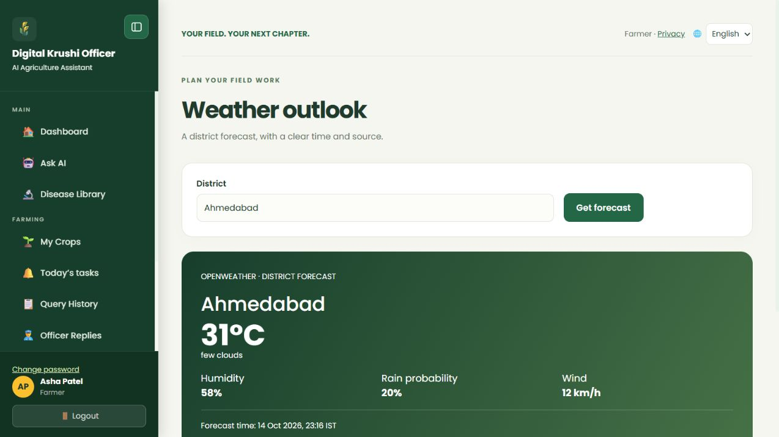
Figure 16. Read the weather outlook in the demo website.
- Open Weather and select the available district if the page offers a district control.
- Read temperature, humidity, rain probability, wind and forecast time together.
- Compare the forecast with current local conditions before planning irrigation, spraying or field operations.
- If the forecast is unavailable, check again later rather than treating missing values as clear weather.

Example
A higher rain probability may be a reason to review tomorrow’s outdoor work. It does not prove rain will fall on North Field at a particular minute.

What to know
The screenshot uses demo values. The live page depends on its weather provider and may briefly cache results. This is not a village sensor, a GPS measurement from your farm or a guaranteed rain warning.

20 Find government schemes
Government Schemes presents reference information about agricultural support. The official scheme portal determines eligibility and application availability.
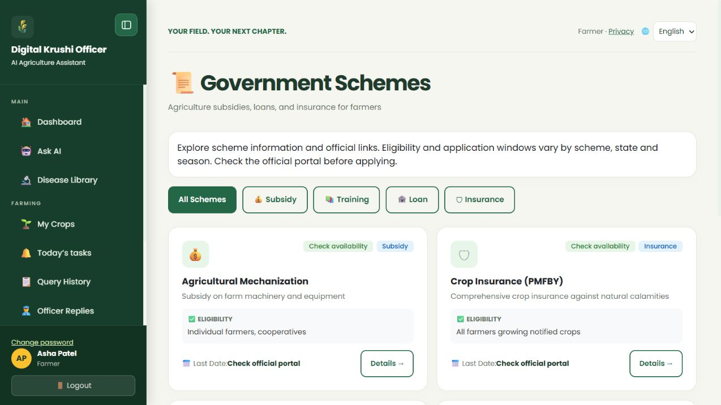
Figure 17. Find government schemes in the demo website.
- Open Gov. Schemes and select All, Subsidy, Loan, Insurance or Training to narrow the list.
- Open a scheme card and read its description, eligibility, dates and application guidance.
- Use the official website link provided in the detail view to check the latest rules and how to apply.
- Check whether your crop, location, documents and farmer category qualify before starting an application.

Example
Select Insurance, open the relevant crop-insurance scheme and check the official enrollment window for your district and season.

What to know
The website is a guide, not an approval system for benefits. A blank last date means no deadline was recorded here; it does not guarantee that applications are open. Do not enter sensitive documents on an unverified third-party page.

21 Maintain the farmer profile
Your profile holds contact, location and general farming information. Individual crop records remain separate from the profile’s Main Crop field.
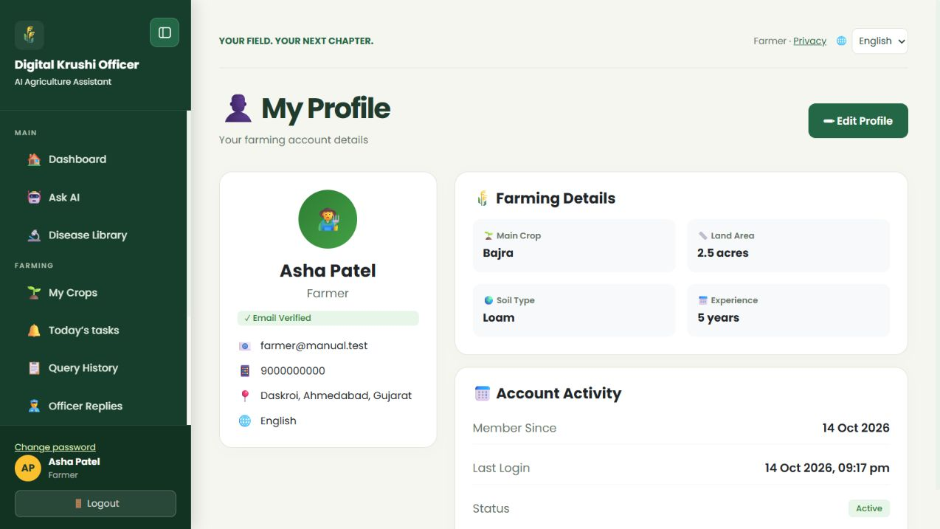
Figure 18. Maintain the farmer profile in the demo website.
- Open My Profile and select Edit Profile.
- Review name, mobile, location and Preferred Language. Enter Main Crop, land area, soil type and farming experience when known.
- Select Save Changes and check the updated profile. Keep account contact information accurate for service messages.
- Use My Crops to maintain field-specific varieties and dates. Do not expect changing Main Crop in the profile to update every crop record.

Example
Asha records Loam as the general soil type and Bajra as Main Crop, while her My Crops records contain separate fields and sowing cycles.

What to know
Use factual values you know. If a detail is uncertain, supply that uncertainty in the AI conversation rather than inventing a measurement. Privacy and language controls are available from the header; password changes use the separate Change password page.

22 Use the officer dashboard and queues
The officer workspace supports expert review of assigned difficult cases. It is not a queue of every question answered by AI.
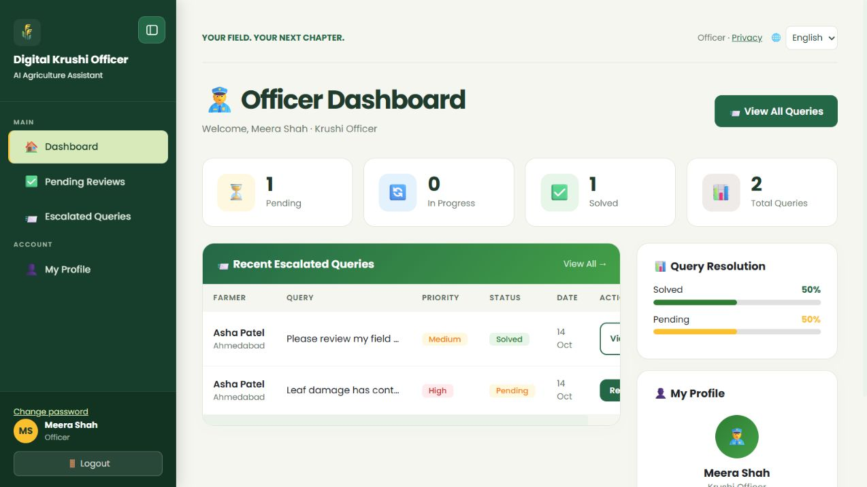
Figure 19. Use the officer dashboard and queues in the demo website.
- After email verification and administrator activation, sign in to the Officer dashboard.
- Read Pending, In Progress, Solved and Total Queries, then open the recent case or View All Queries.
- Use Pending Reviews for private AI responses awaiting approval or correction. Use Escalated Queries for the assigned case list.
- Filter escalations by status and open Reply or View on the relevant row.
- Review the farmer’s question, crop information and earlier conversation before deciding what to send.

Example
Meera sees a persistent leaf-damage case assigned to her. She reads the earlier clarifications and reviews the draft rather than asking the farmer to repeat everything.

What to know
An officer can work only on cases assigned to that officer. An empty queue can mean there are no matching assigned cases. Simple questions solved by AI do not need routine administrator assignment.

23 Review and publish an AI draft
A draft in Pending Reviews is private. Approve it only after checking that it is suitable for the actual question and field context.
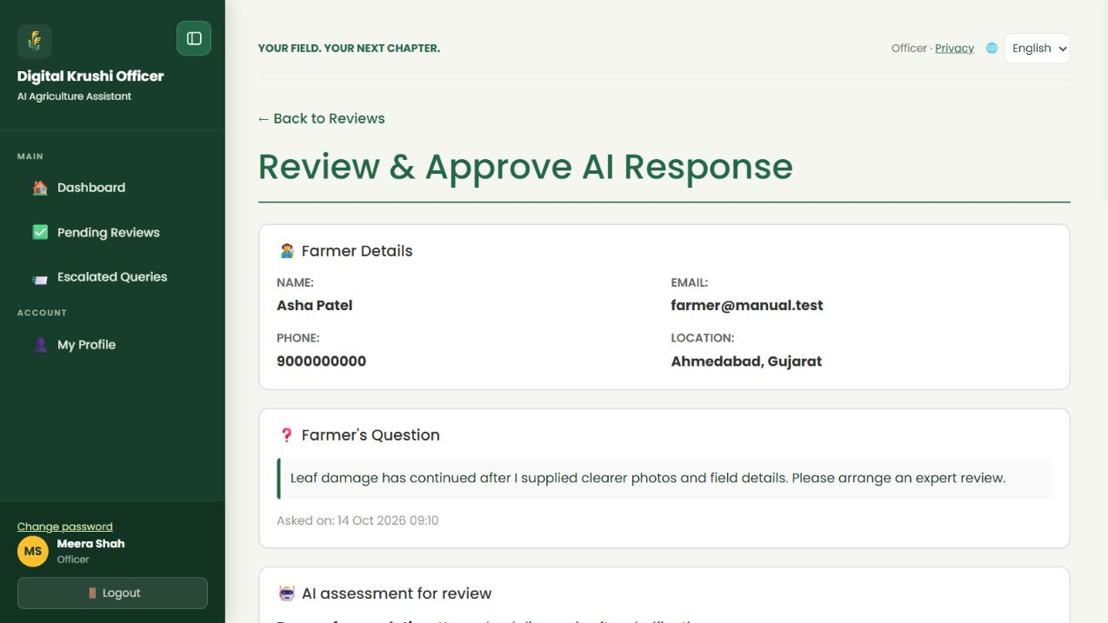
Figure 20. Review and publish an AI draft in the demo website.
- Open Pending Reviews and select the response to review.
- Read Farmer Details, Farmer’s Question and the reason for escalation. Expand Earlier conversation and photos to review supporting evidence.
- If the answer is correct and complete, add optional officer notes and select Approve Response under Approve As-Is.
- If corrections are needed, use Edit & Approve, replace the answer with a clear response, explain your changes and select Modify & Approve.
- Return to the queue and confirm the item is no longer waiting for that action. The reviewed answer is published for the farmer.

Example
The draft overstates a disease diagnosis. The officer removes that claim, explains the uncertainty and adds the field observations needed to decide the next step, then publishes the corrected answer.

What to know
A missing or Not measured confidence value is not a calculated probability of correctness. Read the evidence and reasoning. Modified answers support up to 16,000 characters; officer notes support up to 1,000. Unavailable-provider placeholders cannot be approved as agricultural answers.

24 Mark a draft for revision
Mark for revision rejects the draft for correction. It keeps the case available for further work and keeps the draft private.
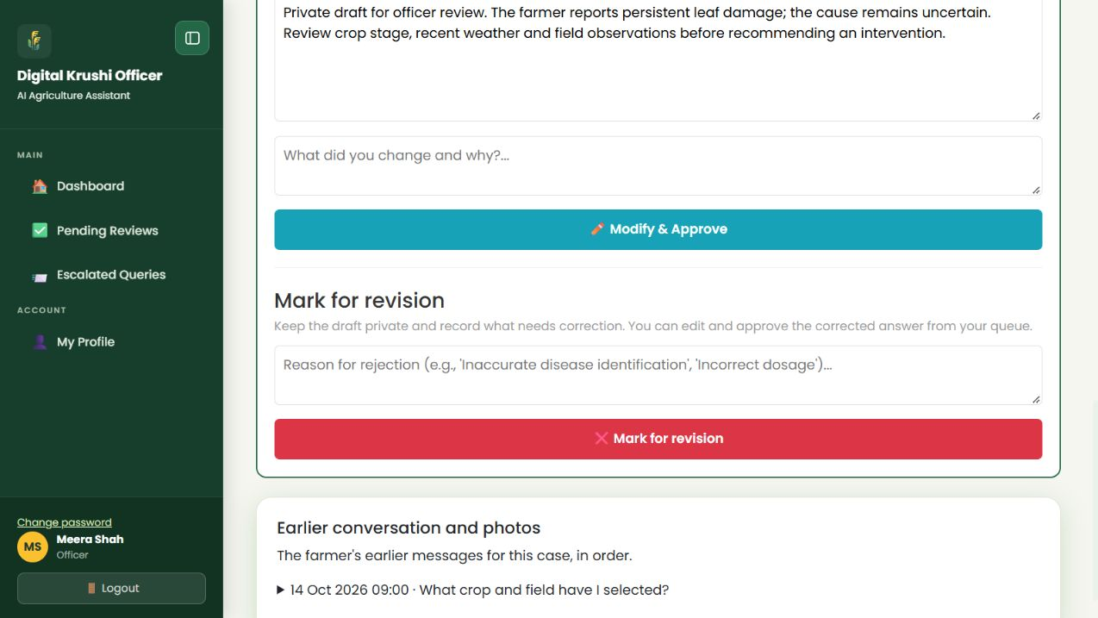
Figure 21. Mark a draft for revision in the demo website.
- In Review & Approve AI Response, locate Mark for revision.
- Enter a specific reason describing what is wrong or missing. Select Mark for revision.
- The query becomes NeedsRevision and the escalation remains in progress. The item can remain in the review queue for correction.
- Open the case again, correct the answer under Edit & Approve, and use Modify & Approve when it is ready for the farmer.

Example
Reason: “The image does not support a definite disease identification. Remove the diagnosis and ask for a clear underside view and recent irrigation details.” The officer then prepares a corrected answer.

What to know
This action is different from rejecting the farmer’s case through Escalated Queries. Mark for revision does not mean the farmer’s question has been permanently closed. A reason is required; keep it within the form’s limit, up to 950 characters.

25 Reply solve or reject an escalated case
The direct reply form sends your expert message to the farmer. Choose a status that describes the case after the reply.
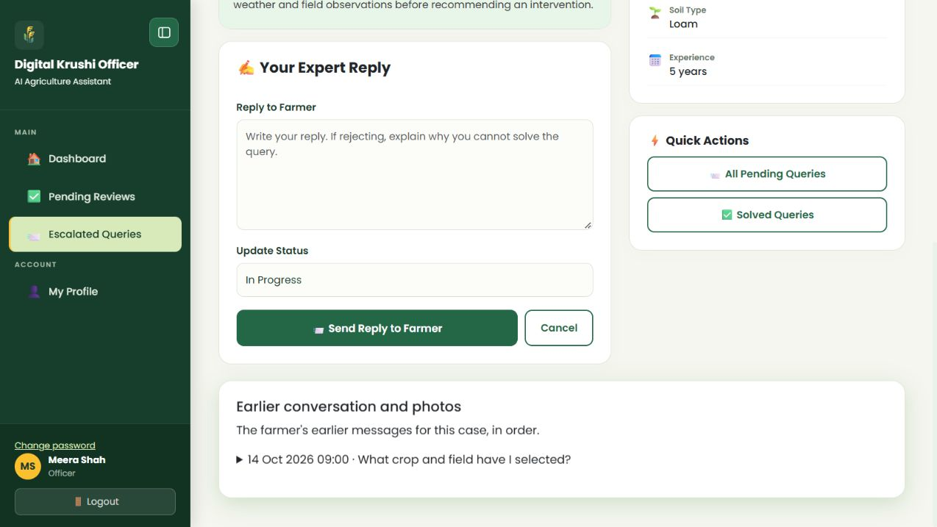
Figure 22. Reply solve or reject an escalated case in the demo website.
- Open Escalated Queries → Reply for an assigned Pending or In Progress case.
- Read the farmer’s profile, draft and earlier conversation. Enter Reply to Farmer with clear advice or the reason you cannot solve the case.
- Choose In Progress to send an update while keeping the case open; Mark as Solved when your reply resolves it; or Reject / Unable to solve when closing it with a reason.
- Select Send Reply to Farmer and verify the case’s new status in the list.
- For a rejection, explain the limitation and a useful next step, such as a local inspection or laboratory test when appropriate.

Example
“These photos do not establish the cause and a field inspection is required. Please contact the local agricultural office with these observations.” Select Reject / Unable to solve only when this is the actual case outcome.

What to know
A non-empty reply or rejection reason is required, with up to 16,000 characters. Solved publishes the expert answer. In Progress sends an update but leaves the case open. Solved and Rejected cases are closed; refresh if another action has already closed the case. Email notification depends on the configured mail service.

26 Maintain the officer profile
Your professional profile helps identify you and the expertise associated with your replies.
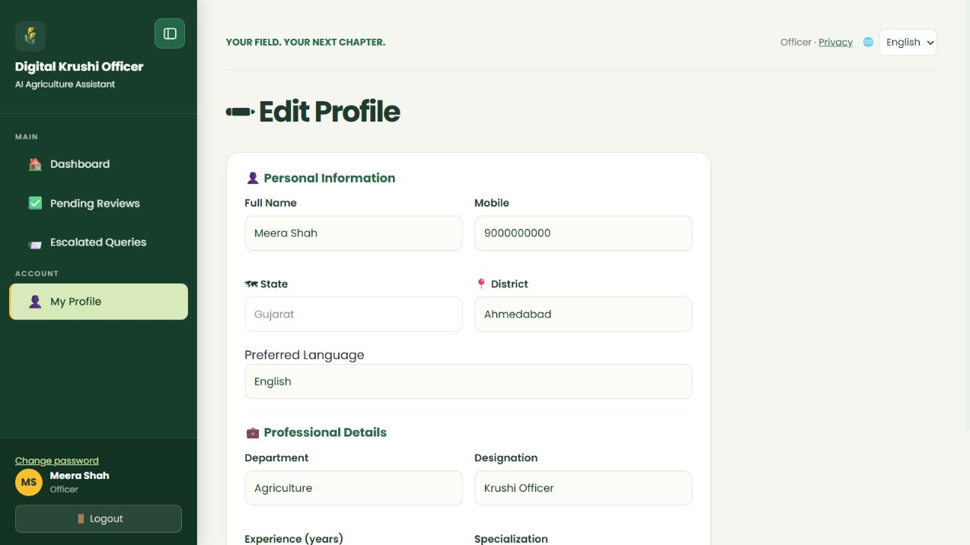
Figure 23. Maintain the officer profile in the demo website.
- Open My Profile → Edit Profile.
- Update name, mobile, available state and district, and Preferred Language.
- Review Department, Designation, Experience in years and Specialization. Use accurate professional information.
- Select Save Changes and verify the profile. Use Change password separately for credential changes.

Example
Meera lists Agriculture as her department and Crop and soil advisory as her specialization. She selects English for her own interface without changing the farmer’s saved preference.

What to know
Editing your profile does not grant access to another officer’s cases. If an expected case is missing, ask the administrator to check the assignment instead of trying another officer’s account.

27 Use the administrator dashboard
The administrator maintains account access, case routing and reference catalogs. The dashboard provides counts and shortcuts to management pages.
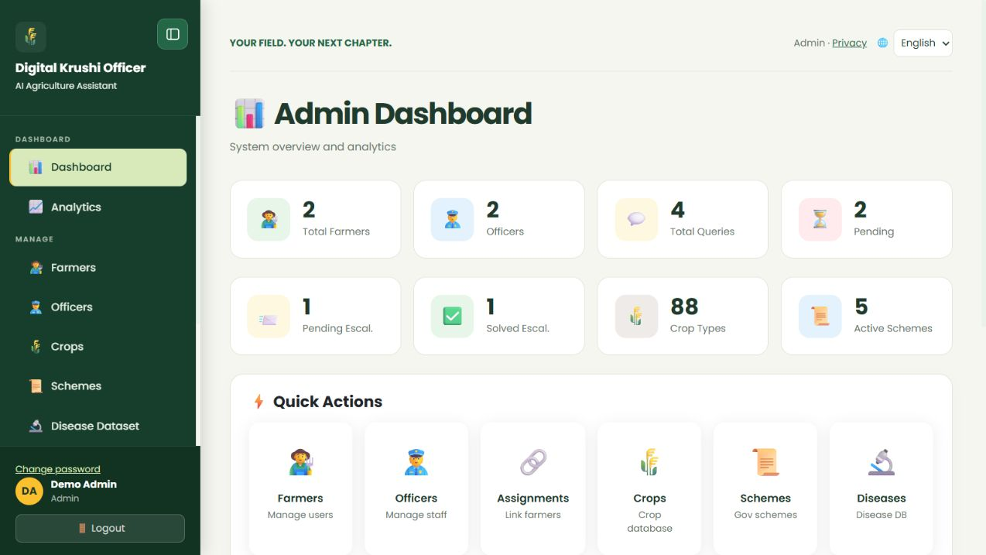
Figure 24. Use the administrator dashboard in the demo website.
- Sign in using the separately provided administrator account. Public registration does not offer an Admin role.
- Read farmer, officer, query, escalation, crop and active-scheme counts. Open the corresponding page for the actual records.
- Check Review queue for difficult cases that have no officer. Check Officers for verified accounts waiting for activation.
- Use Farmers, Farmer assignments, Crops, Schemes and Disease Dataset for maintenance, and All Queries, Feedback and Analytics for reporting.

Example
A verified new officer is waiting for activation and a difficult query is Unassigned. The administrator checks the officer’s details, activates the account where appropriate, then assigns the case.

What to know
Counts are operational summaries, not measured AI accuracy. Most farmer questions should continue through AI without manual administrator routing. Administrators should maintain records using verified source information.

28 Manage farmers and officer access
Account activation controls who can use the website. Review identity and role details before changing access.
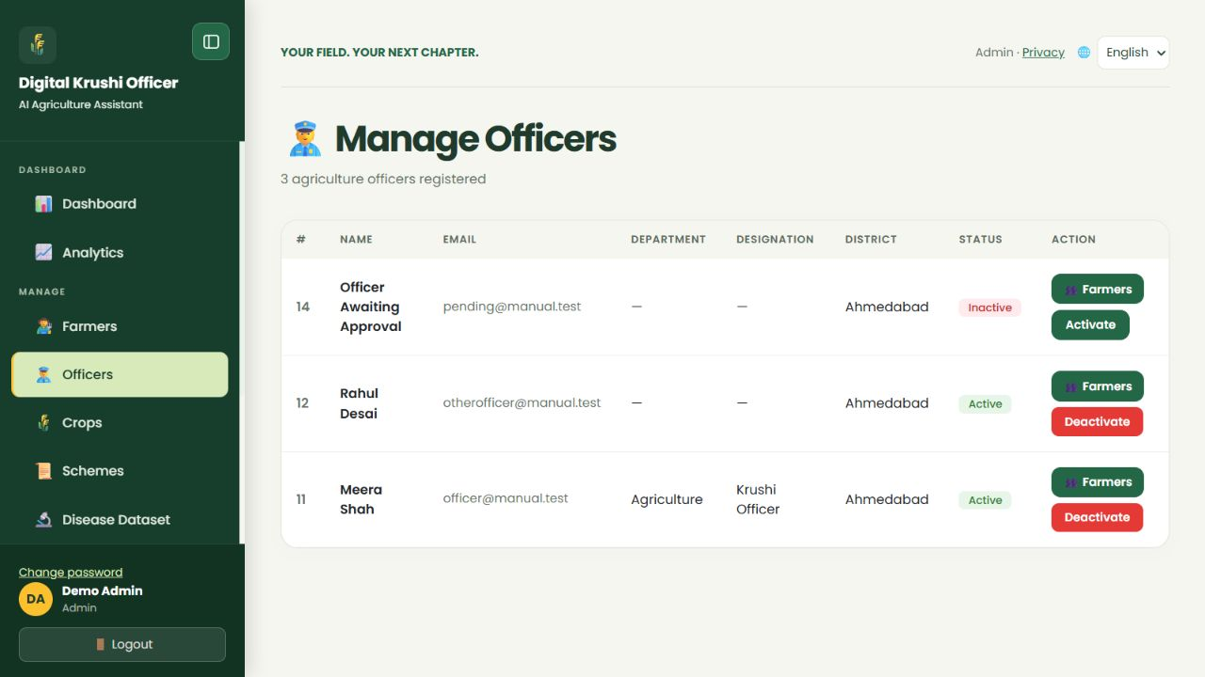
Figure 25. Manage farmers and officer access in the demo website.
- Open Farmers to list farmer accounts. Search by name, email or district and read the current status.
- Use the status action to activate or deactivate a farmer when appropriate. Deactivation controls access; it is not record deletion.
- Open Officers to review officer accounts and verification or activation status.
- Activate only an email-verified officer. If verification is missing, the officer must complete it first.
- Use the officer’s farmer-list action to inspect linked farmers. Review assignments when staff availability changes.

Example
An officer verified their email but remains inactive. The administrator checks the registration and activates the account; the officer can then enter the officer workspace.

What to know
Do not use deactivation as a substitute for correcting an incorrect record. The activation action cannot bypass email verification. Account changes can affect future routing, so keep officer availability current.

29 Assign a preferred officer to a farmer
Farmer assignments link a farmer to a preferred officer for future difficult cases. They are separate from assigning one specific query.
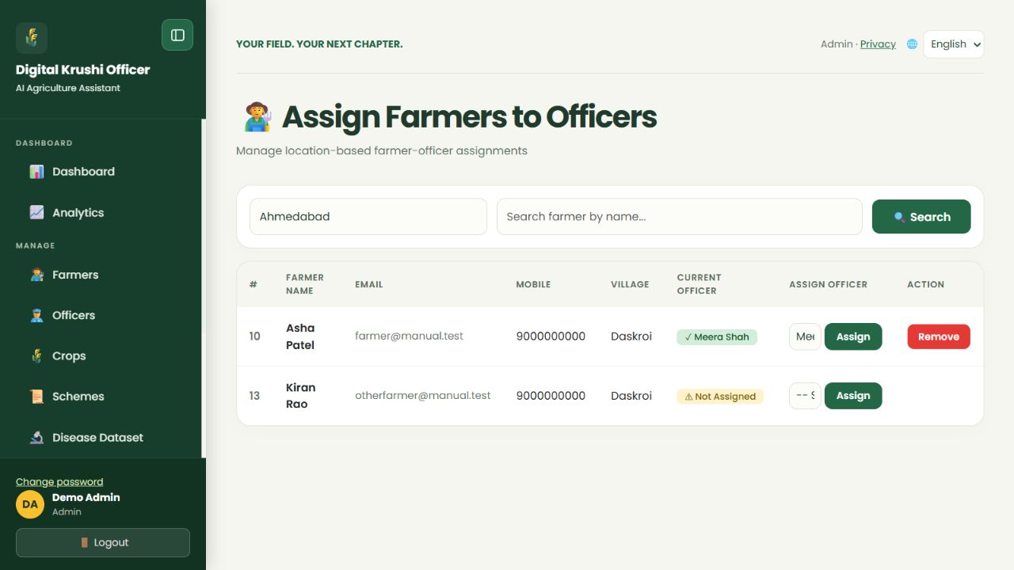
Figure 26. Assign a preferred officer to a farmer in the demo website.
- Open Farmer assignments from the sidebar.
- Filter by district or search for a farmer. Read the current assigned officer if one exists.
- Choose an active, verified officer for the farmer and select Assign.
- Use Remove to remove the preferred link when appropriate. Use the officer’s Farmers button to review linked farmers. Scroll a wide table horizontally if its action column is outside the visible area.
- For an already Unassigned question, open Review queue and assign that specific query separately.

Example
Asha is linked to Meera as her preferred officer. When a later crop question needs expert review, the routing can use that suitable available officer.

What to know
This link does not send every simple question to the officer and does not automatically reassign all existing cases. If a preferred officer is unavailable, the workflow can look for another suitable active, verified officer.

30 Assign an unassigned difficult query
Review queue lists unanswered queries, including unassigned cases and cases already assigned for review. Use each status and case context to identify which difficult questions need routing.
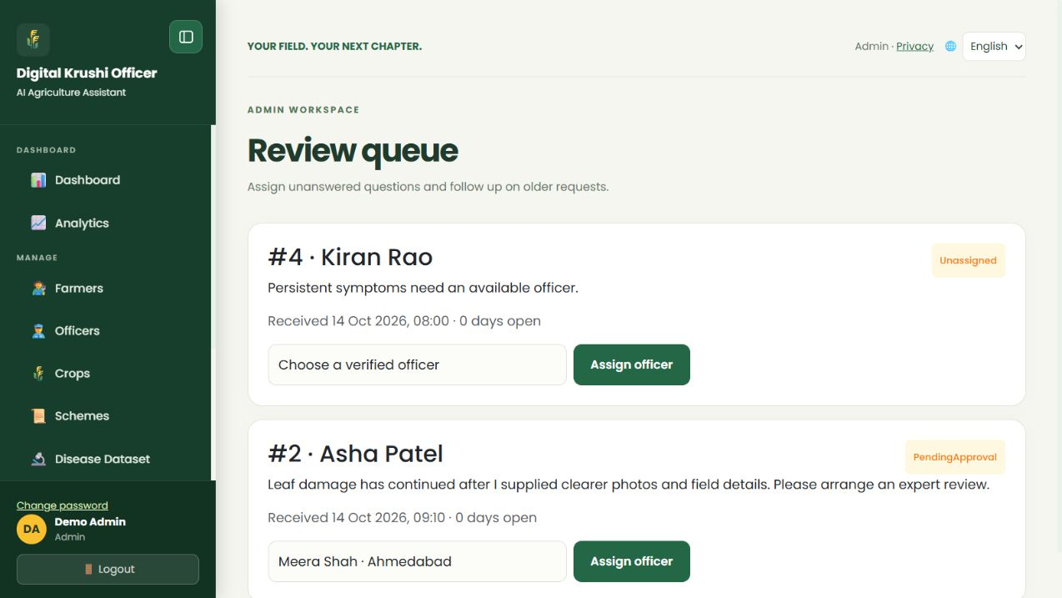
Figure 27. Assign an unassigned difficult query in the demo website.
- Open Review queue and read the farmer’s question, status and any reason for review.
- For an unassigned difficult case, choose an active, verified officer who can handle it and select Assign officer. Review any existing assignment before changing it.
- Verify PendingApproval and the selected officer in the queue. Assigned unanswered cases can remain listed until answered; the case is now available to that officer.
- The officer reviews the draft and conversation, then publishes a corrected answer or replies to the farmer.

Example
A persistent crop issue is Unassigned because no verified officer was available. After activating a suitable verified officer, the administrator assigns that case from Review queue.

What to know
Do not assign every image query merely because it contains photos. Clear, answerable photos can stay with AI. An AI quota error is a technical retry issue, not by itself an agricultural case that needs expert review.

31 Manage the shared crop catalog
Admin Crops defines the crop choices available to farmers. It is different from a farmer’s own crop records and calendar.
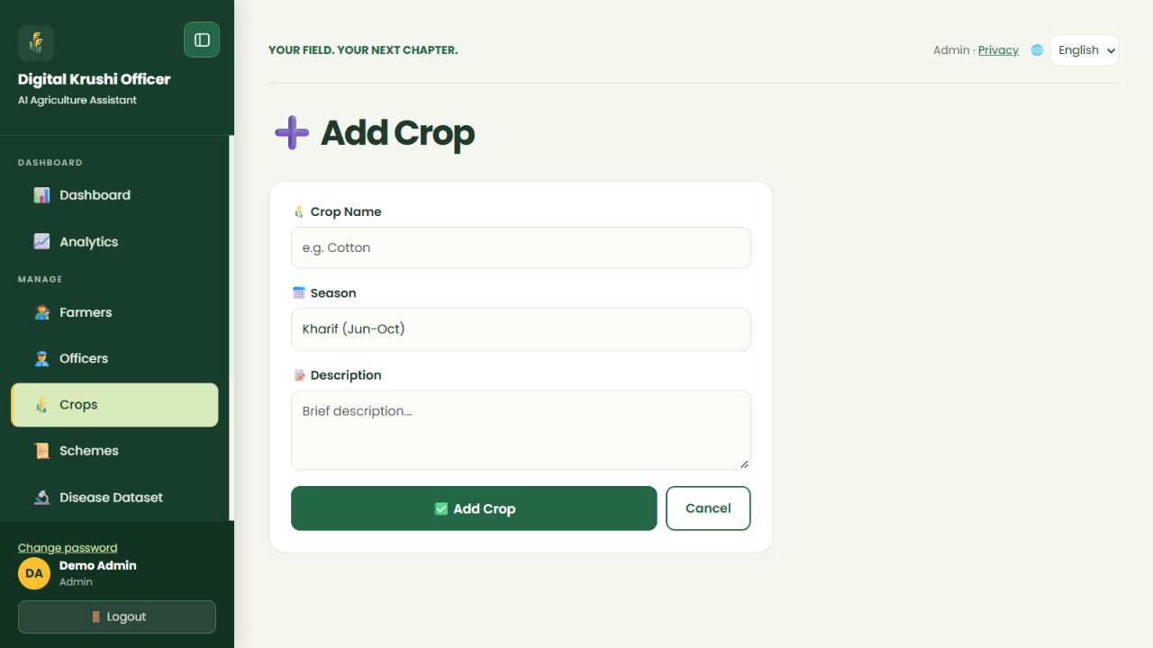
Figure 28. Manage the shared crop catalog in the demo website.
- Open Crops to view the shared catalog. Select Add Crop to create a shared crop type.
- Enter Crop Name, choose Kharif, Rabi, Zaid or Year-round, and add a useful description. Select Add Crop.
- Use Edit on an existing crop to correct its name, season, description or active setting, then save.
- Use the active-status control to stop offering an outdated catalog choice or to restore it.
- Check the farmer Add Crop selector to verify the active catalog entry appears.

Example
Add a genuinely missing crop using its commonly recognized name and appropriate season. Avoid duplicate names or adding a specific farmer’s field name as a crop type.

What to know
A farmer’s Other option creates a personal name, not an admin catalog row. Deactivating a shared crop is not the same as deleting a farmer’s planted crop. A season label describes a catalog category; it is not a guaranteed sowing or harvest date for every location.

32 Maintain government scheme records
Keep reference scheme information accurate and distinguish visibility from application status.
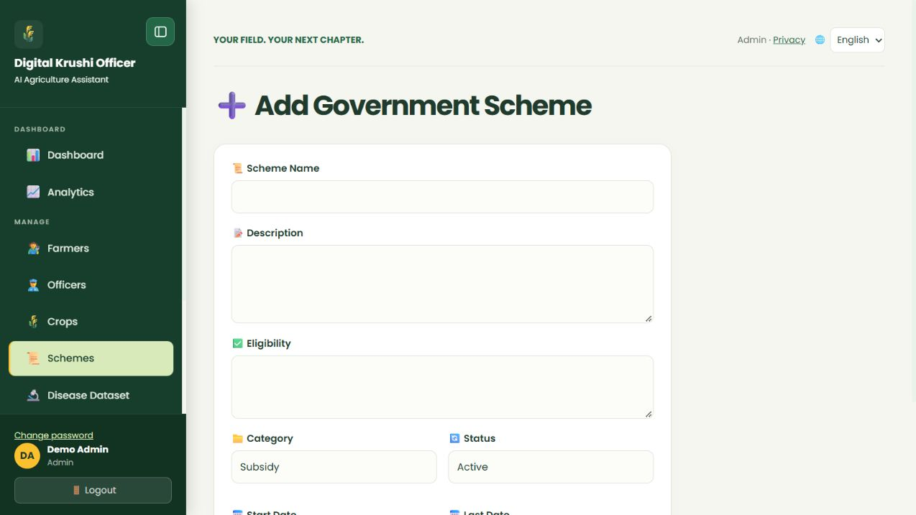
Figure 29. Maintain government scheme records in the demo website.
- Open Schemes and select Add Scheme.
- Enter Scheme Name, Description and Eligibility. Choose Subsidy, Loan, Insurance or Training.
- Set the scheme Status to Active, Expired or Draft and enter known Start Date and Last Date. Select Add Scheme.
- Use Edit to correct an existing record, or use the active-status control to change its visibility.
- Verify the farmer-facing scheme list and detail view. Check the official portal before publishing dates or eligibility claims.

Example
For an insurance scheme, record the actual eligibility and known enrollment dates from its official source. If no confirmed deadline is available, leave the date unspecified rather than inventing one.

What to know
The current add form does not include an arbitrary external application-URL field. Scheme details may supply an official resource link through the website’s scheme guidance. A record marked Active does not itself approve a farmer or prove that enrollment is open today.

33 Maintain the disease reference dataset
Disease Dataset supplies the farmer library and reference knowledge. Publish reviewed, crop-specific information rather than unsupported diagnoses.
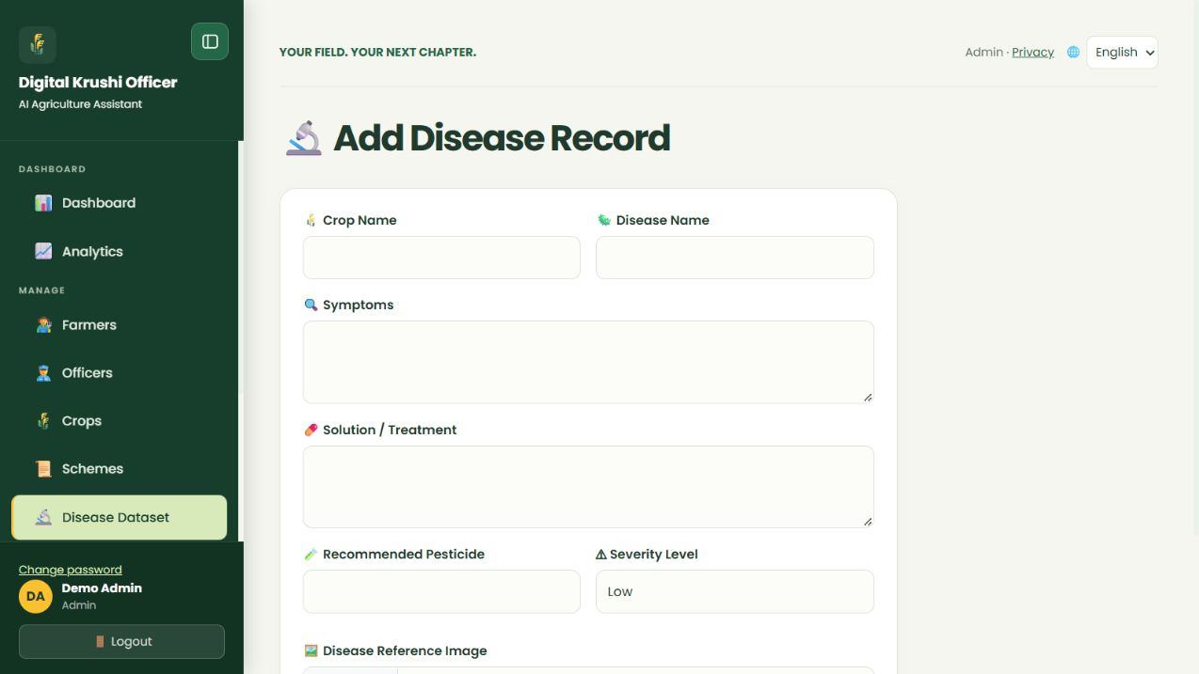
Figure 30. Maintain the disease reference dataset in the demo website.
- Open Disease Dataset and select Add Disease.
- Enter Crop Name, Disease Name, Symptoms and Solution / Treatment. Add recommended pesticide information only when supported.
- Select Low, Medium, High or Critical severity. Optionally attach a reference image and review the preview.
- Select Add Disease. Use Edit to correct an existing record and the active-status control to hide or restore a record.
- Check the farmer Disease Library card and detail view for clarity and correct crop association.

Example
Add a reference record with observable symptoms and a reviewed treatment description. Use an image you have permission to use and identify it as reference material, not a farmer’s confirmed case.

What to know
Reference-image upload accepts JPG, PNG and WebP up to 5 MB. Edit also has Reference Image Path for an existing supported image; it does not upload a replacement file. Use a verified path supplied by the project maintainer. Do not treat severity or a pesticide name as a diagnosis for every similar-looking photo.

34 Inspect queries feedback and analytics
Reporting helps administrators find unresolved work and understand usage. It does not replace expert review of answer quality.
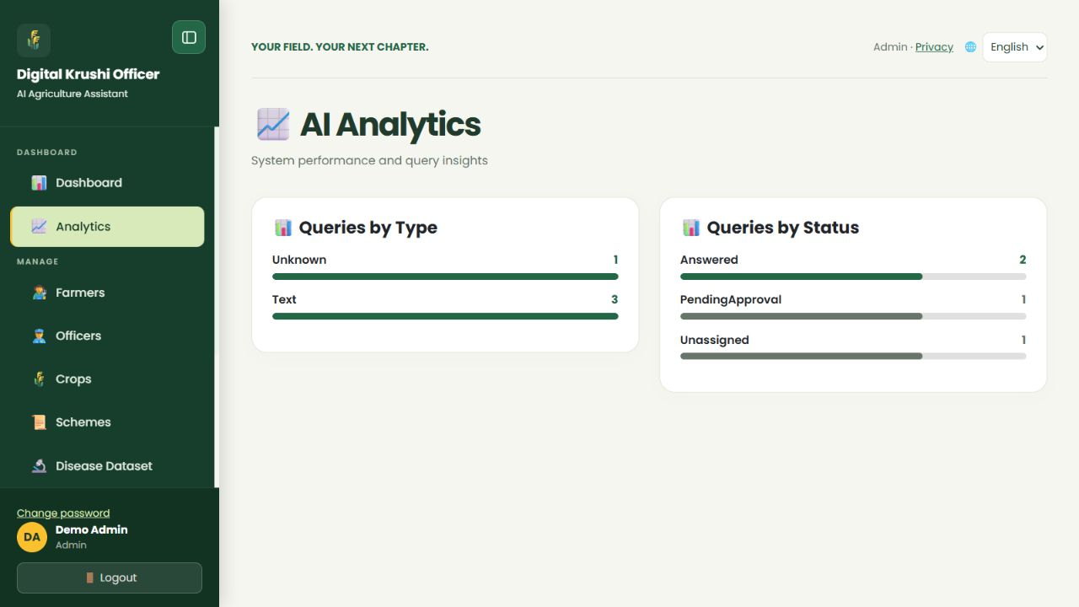
Figure 31. Inspect queries feedback and analytics in the demo website.
- Open All Queries. Search for relevant records, select a status filter and use page navigation for older results.
- Read query type and workflow status together. Use Review queue for unassigned cases rather than assuming every pending label means the same thing.
- Open Feedback to inspect farmer ratings, comments and feedback type where supplied.
- Open Analytics to compare the available query and resolution summaries. Use these trends to identify bottlenecks and content gaps.

Example
If many cases remain Unassigned, review officer availability. If answers receive poor ratings, inspect the actual questions and replies before changing reference information.

What to know
Counts and resolution percentages describe recorded workflow activity. They are not automatically measured model accuracy, diagnosis certainty or a guarantee of farmer outcomes. Respect the privacy of farmer questions and photos when discussing reports.

35 Troubleshoot common problems
Use the message shown on the page to choose the next step. Avoid creating duplicate records or repeatedly submitting the same form.
Problem | What to check
Cannot sign in | Email and password, verification, activation and temporary sign-in limits. Officers need both verification and activation.
AI asks for more information | Reply in the same chat with the requested crop stage, observations or clearer photos.
AI cannot provide a current price | Specify commodity and mandi; read the dated official source. Provider availability and reporting dates can limit results.
Photo rejected | Supported JPG/PNG/WebP, 5 MB each, 20 images maximum and 25 MB total per message.
Today reminder missing | Correct crop, saved date in India time, Growing status and Pending task state. Confirm a suggested plan before expecting its tasks.
Email missing | Crop opt-in, verified email, pending due work, summary status, spam and scheduler timing. Accepted is not inbox confirmation.
Officer rejection fails | Enter a non-empty reason and choose the correct status on an open assigned case. Draft revision uses a different form.
Form reports a conflict | Another tab or user may have changed the record. Refresh and review the current values before submitting again.

What to know
If the free hosted website is waking up, allow it to load before retrying. When reporting a problem to the project maintainer, provide the page name, action, time and error text, with private details removed. Do not send passwords, reset links or API keys.

36 Practice the complete workflow
Use this checklist to learn the website with your own appropriate records. The example illustrates the interaction between roles without requiring every query to reach an officer.
- Farmer: create and verify your account, choose a language and save your profile.
- Farmer: add a crop, save field and variety details, review the suggested calendar and add a custom check for today.
- Farmer: open Ask AI about this crop, ask a simple context-aware question and read the direct answer. Add clear photos and details for a real crop issue.
- Farmer: reply to any clarification request. If the case remains difficult, check its expert-review status and later read Officer Replies.
- Officer: open the assigned case, review earlier evidence, correct or approve the draft, or send a direct reply with the appropriate status.
- Administrator: if the case is Unassigned, check officer verification and availability and assign only that difficult case.
- Farmer: complete or reschedule the reminder after checking the field. Enable email only if desired and understand the daily summary status.
- Farmer: rate the published answer. When actual harvest occurs, confirm the harvest date and preserve the record for reference.

Example
Asha’s simple “Which field is selected?” question stays with AI. Her unresolved leaf-damage case goes to Meera. The administrator intervenes only if routing cannot find an officer. Asha remains responsible for checking field conditions and updating her crop tasks.

What to know
For a quick start, read sections 2–7 and 10–15. Officers should read 22–26; administrators should read 27–34. Section 35 helps resolve common problems. This guide describes available functionality, not guaranteed crop outcomes or exact external-provider response times.

Use footnotes for definitions, assumptions, or terms that need precision without interrupting the main narrative.

